Roll Number: 24BAD071 Date:21-08-2024

24ADC001 — BUSINESS INTELLIGENCE LAB ASSIGNMENT_21.08.2026
One scenario, one dataset, one tool each: Power BI, Tableau, OpenAI, and NotebookLM
LAB 1 — POWER BI

PedalShare: Building an OLAP Cube for a City Bike-Share Network
Concepts covered: data warehouse star schema, OLAP (roll-up, drill-down, slice, dice, pivot), analytic functions (DAX).

Scenario
PedalShare runs a bike-share network across Coimbatore, Chennai, and Bengaluru. Their ops team currently gets a single flat spreadsheet dump every morning and manually eyeballs it — there's no model, no drill-down, no way to compare cities or rider types quickly. You've been brought in to build them their first real analytical model: a proper star schema in Power BI that lets any manager slice the data six different ways before their coffee gets cold.

Dataset: pedalshare_trips.csv
- trip_id, date, city, station_start, rider_type (Member/Casual), bike_type (Classic/Electric), duration_min, weather, temperature_c
- Roughly 1,500 trips across 3 cities over a 90-day period, with real embedded patterns: casual riders take longer trips on weekends, rain shortens trips, and Bengaluru runs a higher volume than the other two cities.

Tasks
- Import the CSV and use Power Query to split it into a Fact_Trips table and at least two dimension tables (e.g., Dim_Date, Dim_City, Dim_RiderType).
- Build the relationships in Model view to complete the star schema.
- Build a Matrix visual with City on rows and Month/Week on columns, and use it to roll up to monthly totals and drill down to weekly, then daily detail.
- Add slicers for rider_type and weather. Produce one sliced view (a single weather condition) and one diced view (a specific city + rider type + weather combination).
- Write a DAX measure using RANKX() to rank stations by total trips, and a second measure computing average trip duration by rider type.
- Investigate: does casual ridership really spike on weekends across all three cities, or is that pattern driven by just one city? Show the visual that answers this.

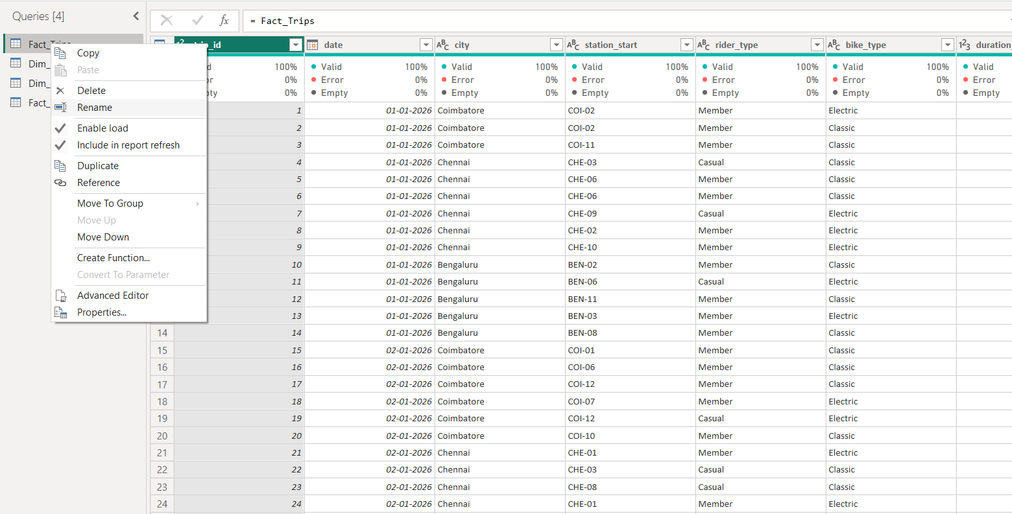
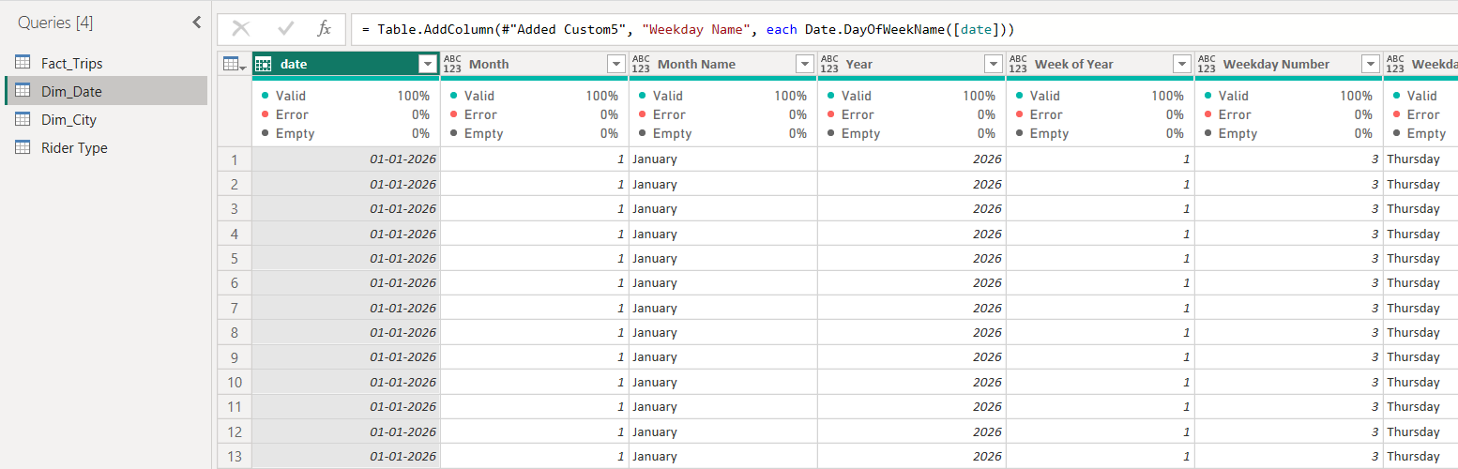

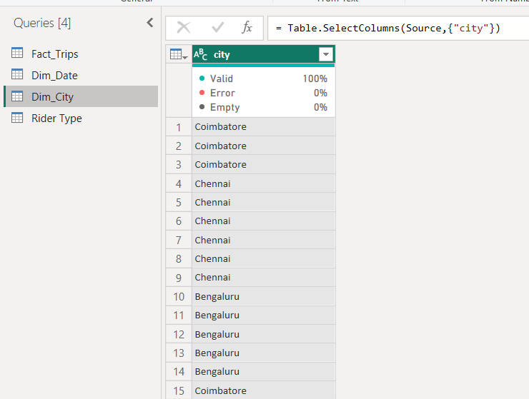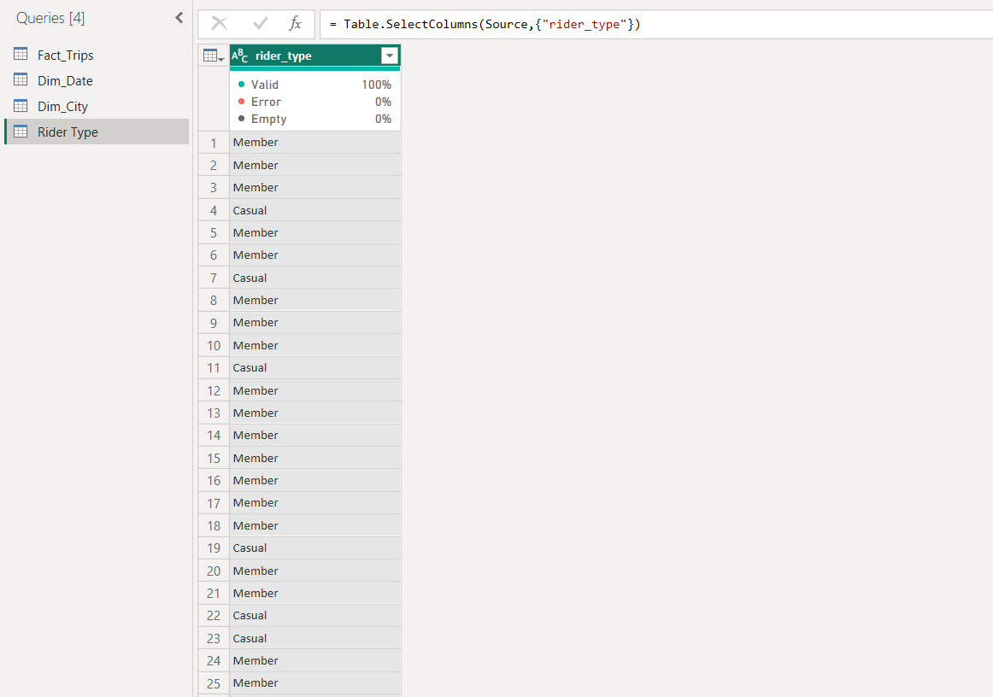

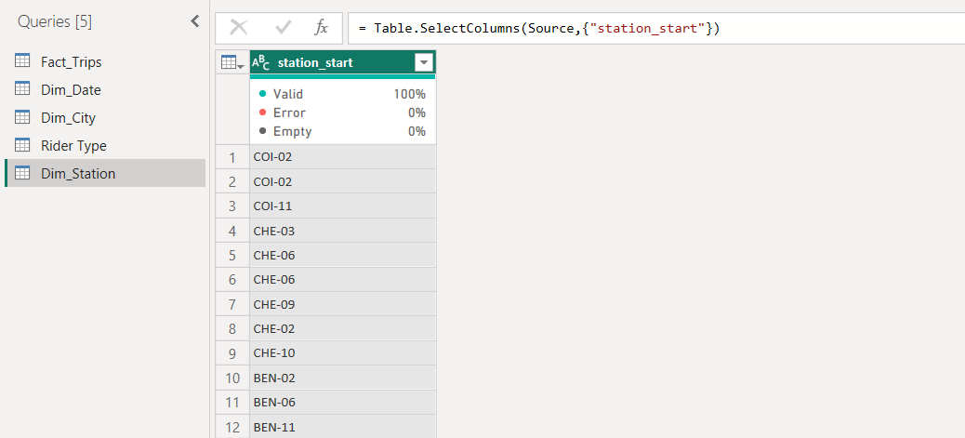

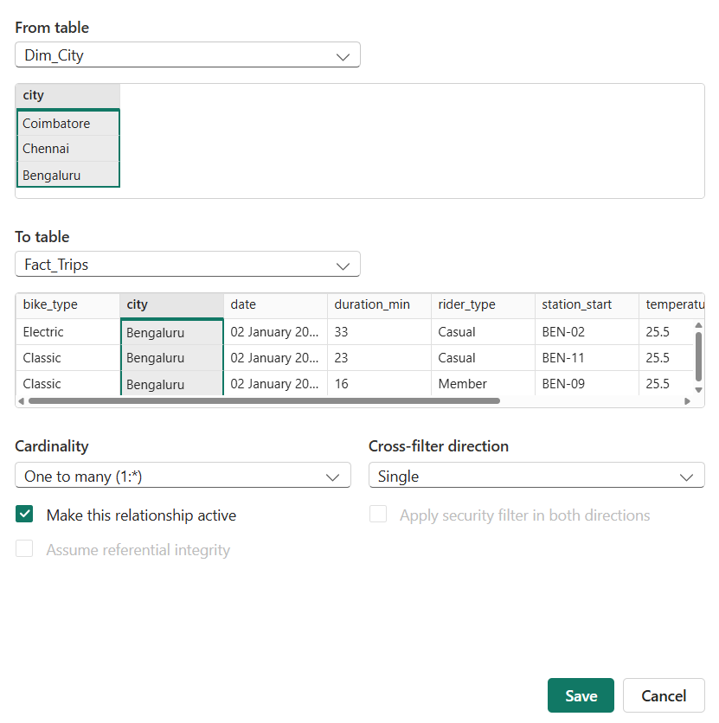
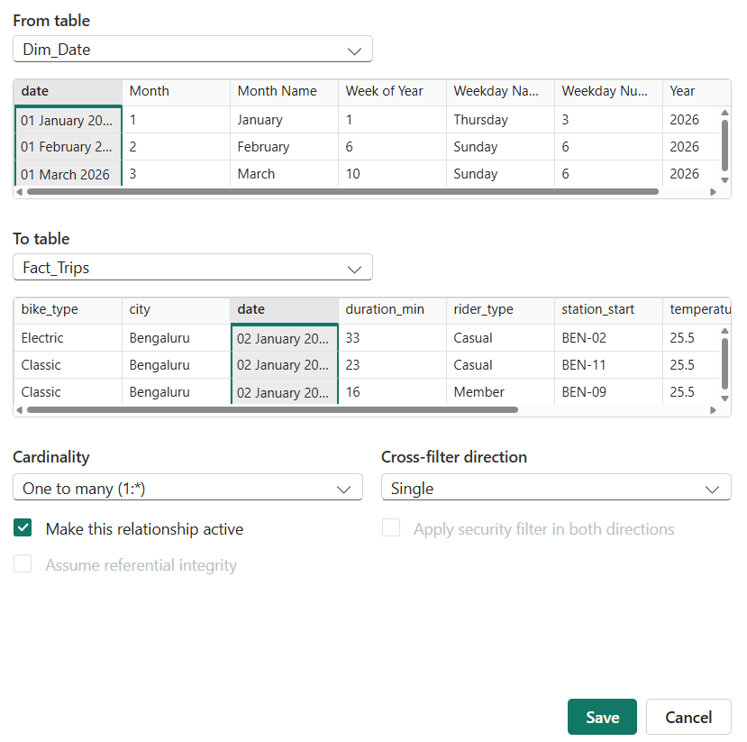
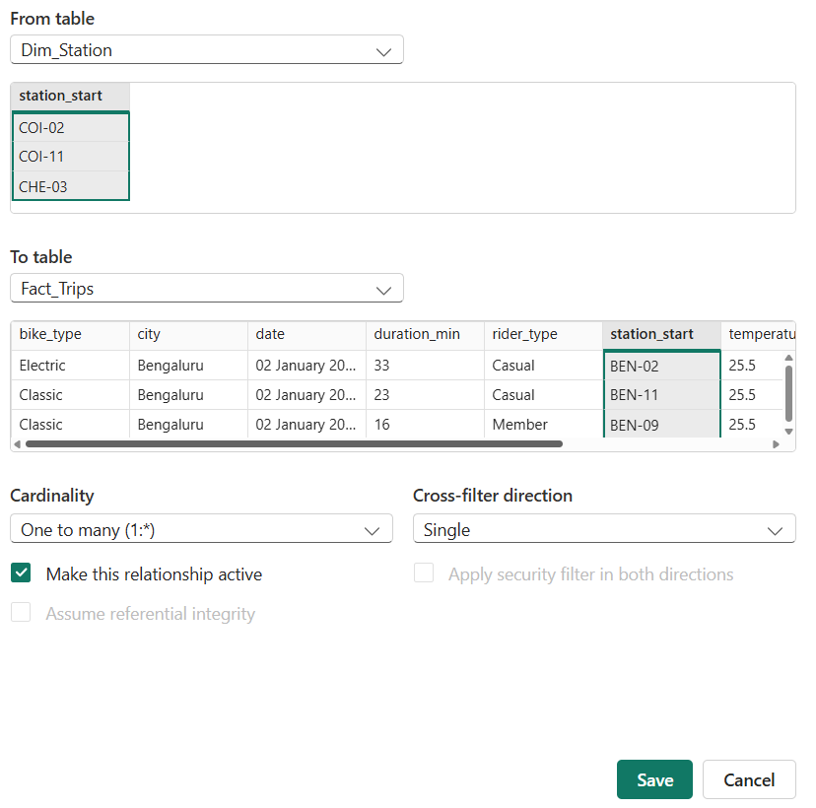

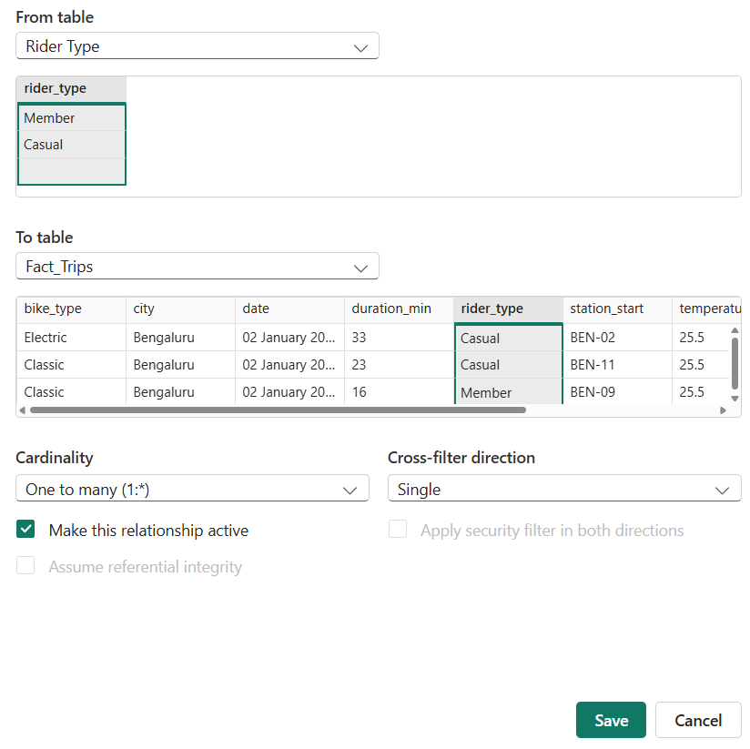
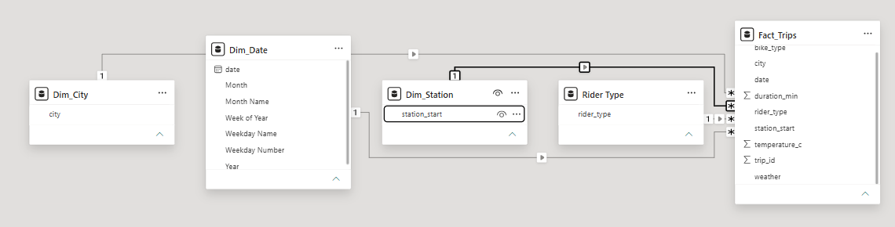

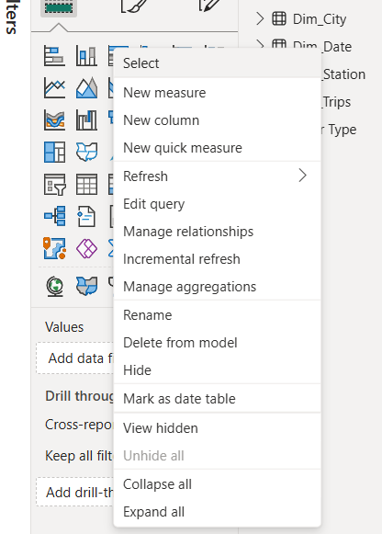

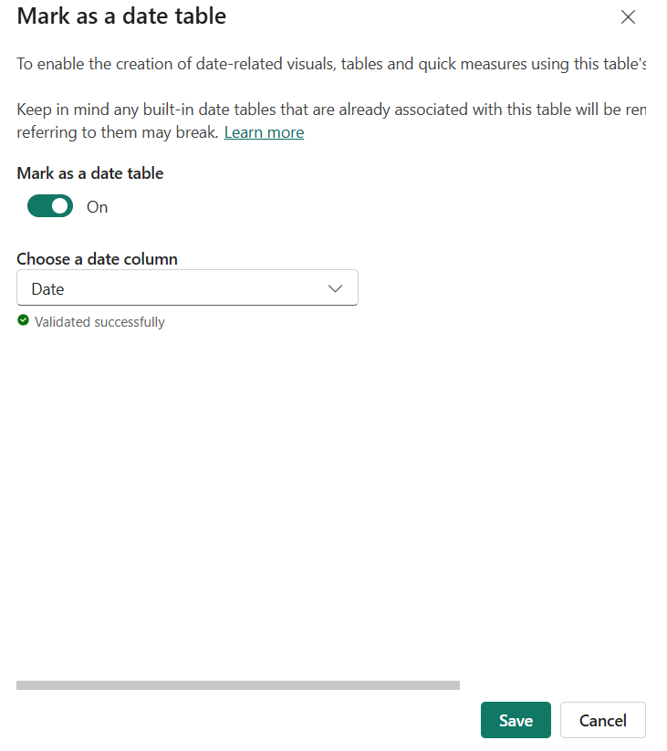

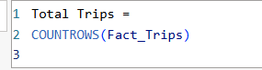

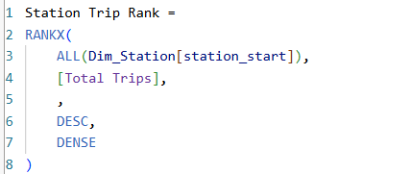

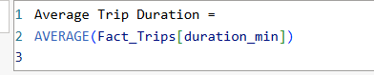

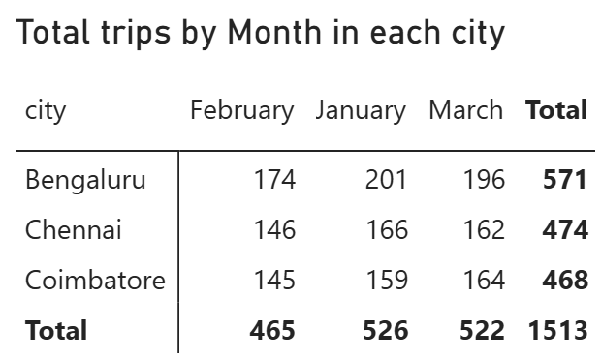

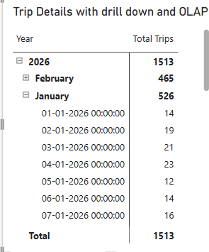
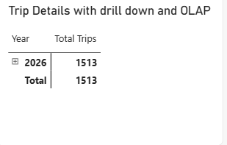
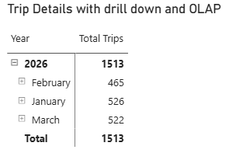

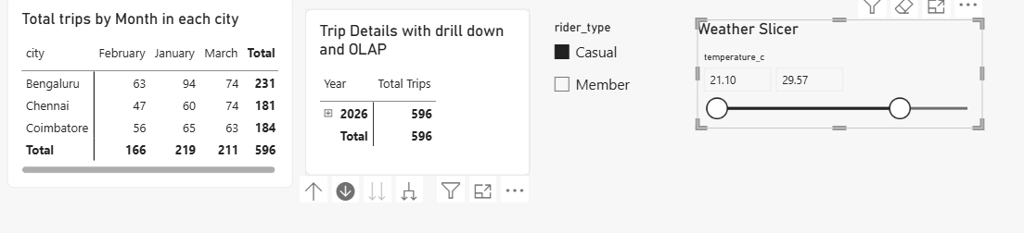

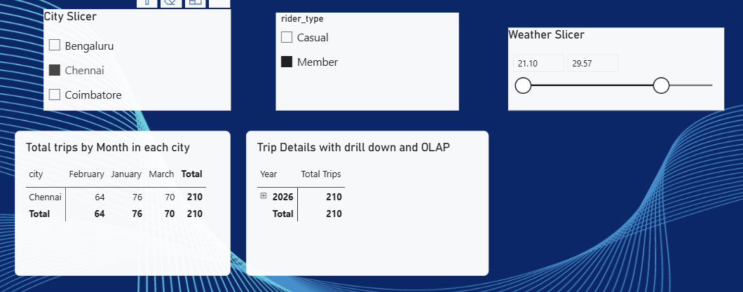

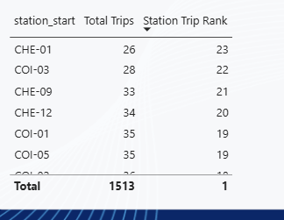

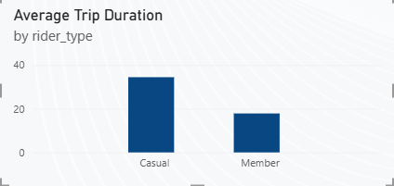

Question:
Does casual ridership really spike on weekends across all three cities, or is that pattern driven by just one city?

Weekend Casual Ridership Analysis

The objective of this analysis is to determine whether casual riders show a significant increase in ridership during weekends and whether this pattern is consistent across the three PedalShare cities: Coimbatore, Chennai, and Bengaluru.

A Clustered Column Chart was created in Power BI to compare casual ridership between Weekdays and Weekends, with the three cities represented separately. The chart uses Day Type (Weekday/Weekend) on the X-axis, Casual Trips on the Y-axis, and City as the legend.

Analysis

The visualization shows that casual ridership is approximately equal for weekdays and weekends across all three cities. Bengaluru, Chennai, and Coimbatore do not show a major difference between their weekday and weekend casual-ridership values.

This means that there is no strong evidence of a weekend spike in casual ridership. If the weekend effect were significant, we would expect the Weekend columns to be noticeably higher than the Weekday columns for one or more cities. However, the chart shows a relatively balanced pattern between the two types of days.

The similarity across all three cities is also important. The result does not suggest that the overall casual-ridership pattern is being driven by a single city. Instead, all three cities exhibit a similar weekday-versus-weekend pattern.

Conclusion

Based on the Power BI visualization, casual ridership does not significantly spike on weekends across the PedalShare network. The ridership levels are relatively consistent between weekdays and weekends in Bengaluru, Chennai, and Coimbatore.

Therefore, the analysis suggests that the weekend effect is not driven by any particular city. Rather, casual riders appear to use the bike-share service at fairly similar levels throughout the week. This finding can help the operations team avoid assuming that additional weekend capacity is required solely because of casual riders.

Supporting Visual:
Clustered Column Chart – Casual Trips by Weekday/Weekend and City

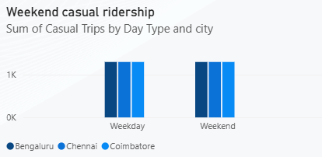

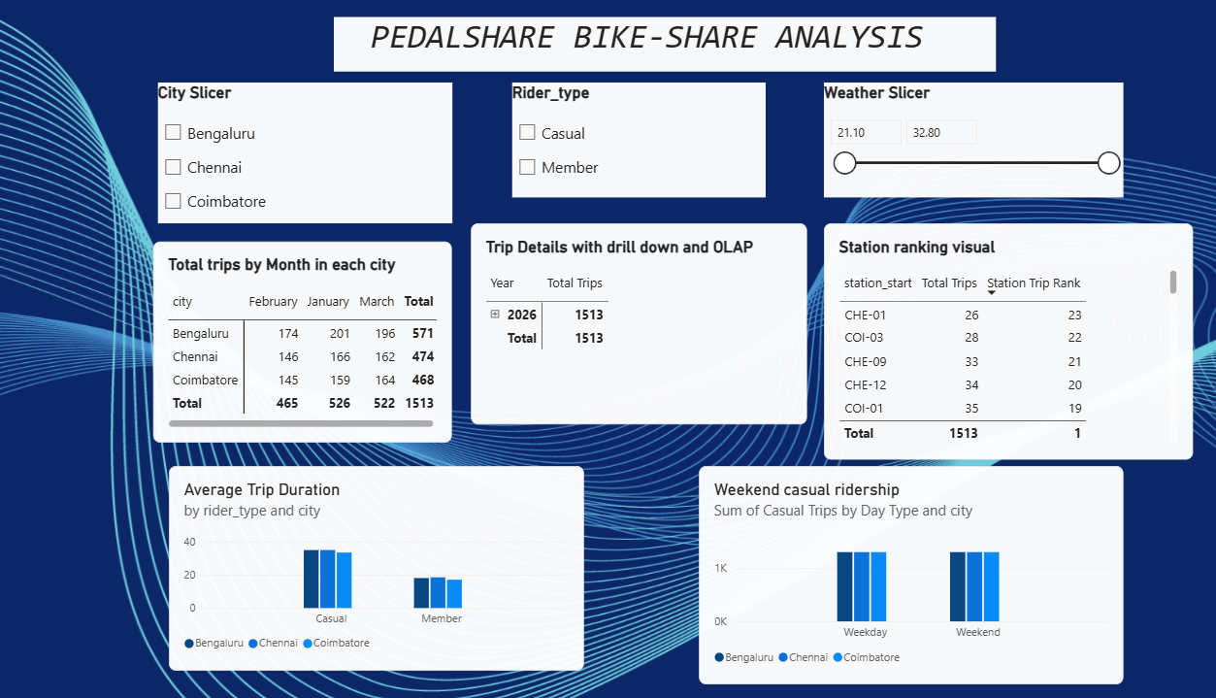

Deliverables
- The .pbix file with the completed model, matrix visual, slicers, and both DAX measures.
- A short write-up answering the weekend-ridership investigation question, with a screenshot of the supporting visual.

LAB 2 — TABLEAU CityCare Hospital: A Decision Support Dashboard for the Emergency Department
Concepts covered: business intelligence dashboards, decision support systems, types of decisions (structured/semi-structured/unstructured).

Scenario
CityCare Hospital's Emergency Department is chronically short-staffed at the worst possible times, and nobody can say with confidence when those times actually are. The department head has a hunch it's “weekend nights,” but hunches don't get budget approved. You've been asked to build a dashboard that turns the hunch into evidence — and to recommend, using it, what kind of decisionmaking process the hospital should actually use to solve the problem.

Dataset: citycare_er_visits.csv
- visit_id, date, arrival_hour, department, triage_level (1=most critical to 5=least), wait_time_min, age_group, outcome, day_of_week
- Roughly 1,700 visits over 120 days, with embedded patterns: wait times scale with triage severity, and weekend nights (6pm–11pm) run heavier volume with a wait-time surge.

Tasks
- Connect Tableau to the CSV and build three linked worksheets: a heatmap of visit volume by day-of-week × hour, a bar chart of average wait time by department, and a breakdown of outcomes by triage level.
- Build a drill-down hierarchy on Department → Triage Level, and demonstrate expanding and collapsing it.
- Add a filter for day-of-week and a parameter to toggle between viewing wait time vs. visit volume — use these to isolate the weekend-night pattern specifically.
- Create a calculated field ranking departments by average wait time using a table calculation.
- Combine the views into one dashboard with an action filter connecting them.
- Write a 200-word recommendation: is “when to add ER staff” a structured, semi-structured, or unstructured decision, based on what the dashboard actually shows? What role should a DSS play here versus a manager's judgment?

Deliverables
- The Tableau packaged workbook (.twbx).
- The 200-word written recommendation.

Tableau:

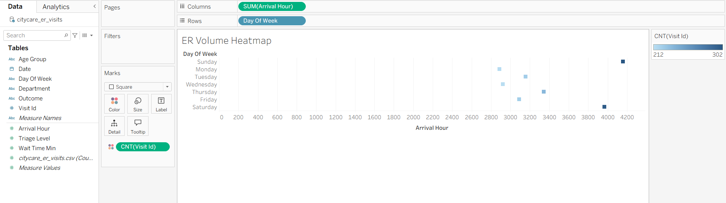

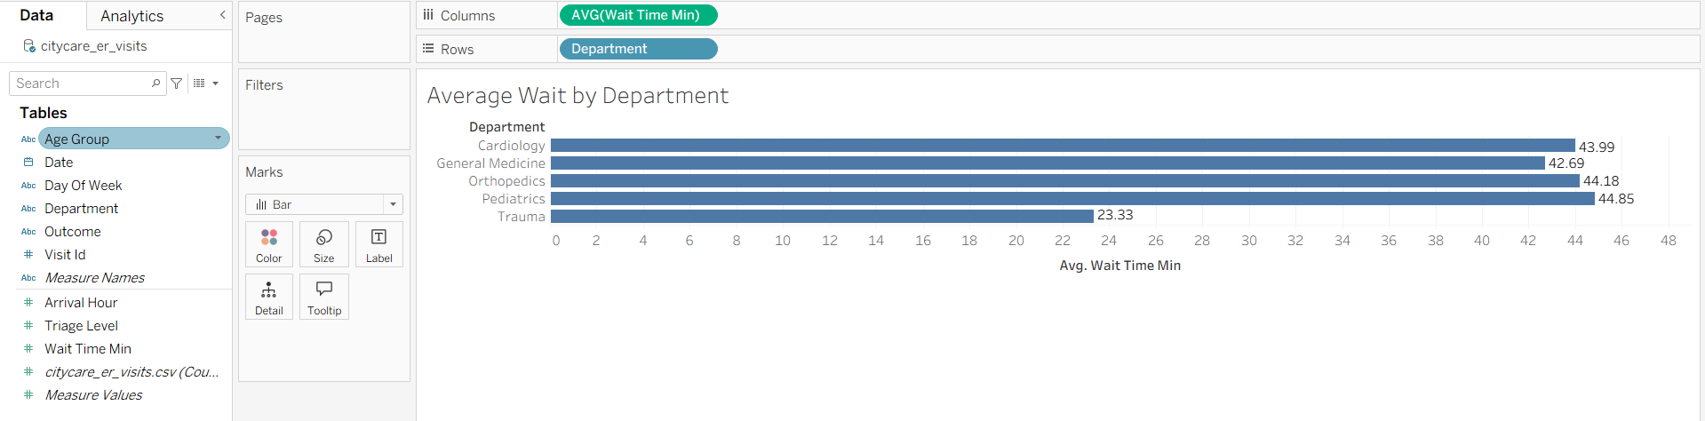

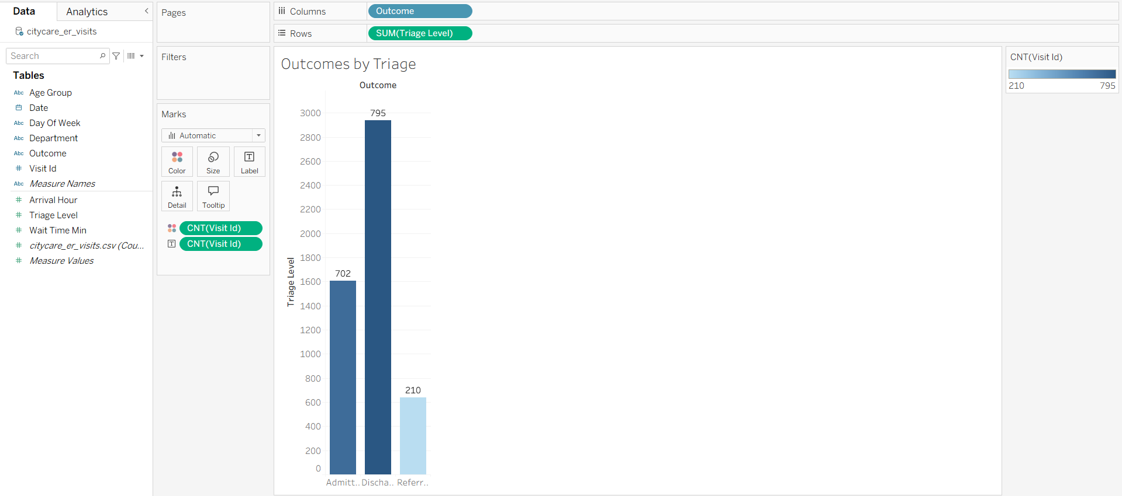

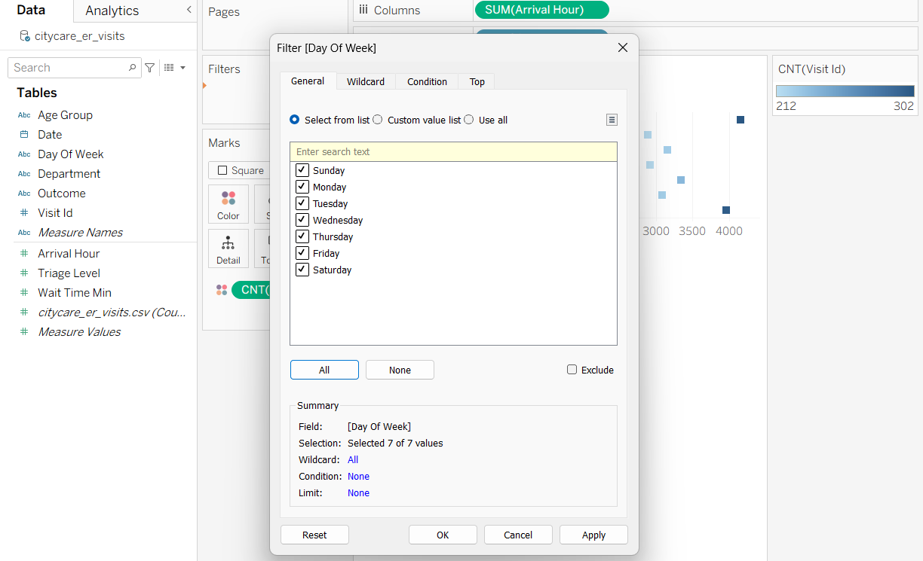

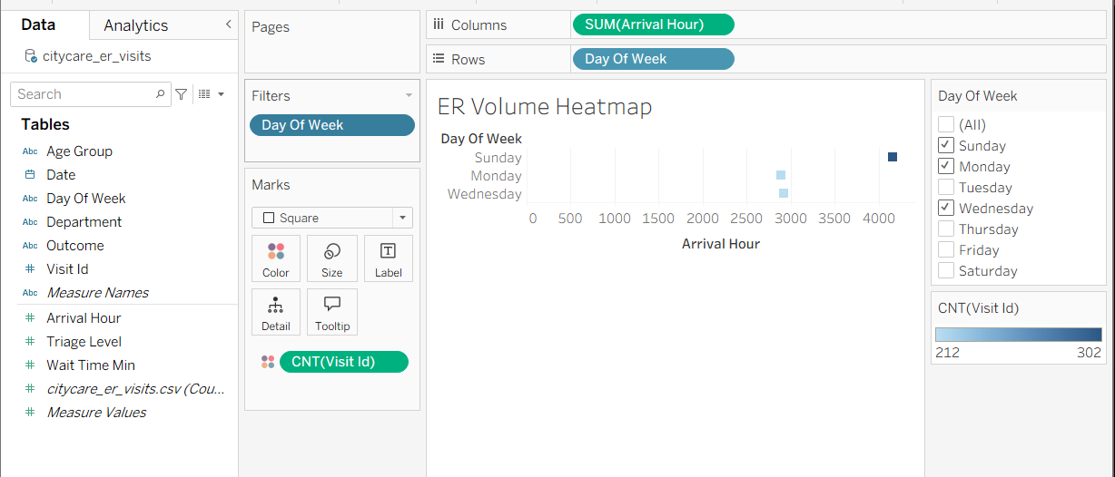

Weekend_Activities:

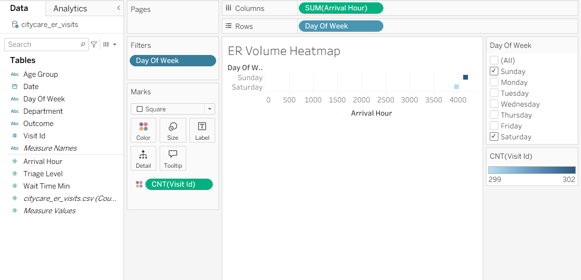

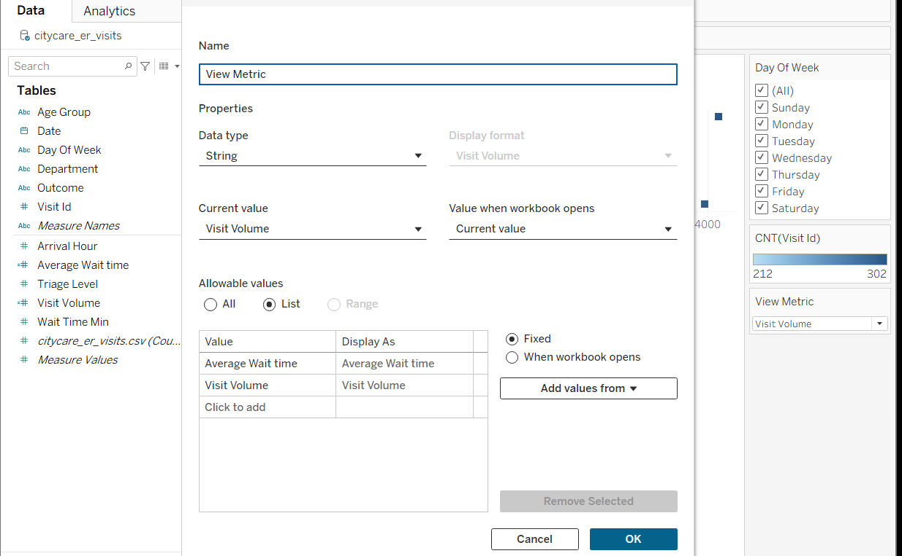

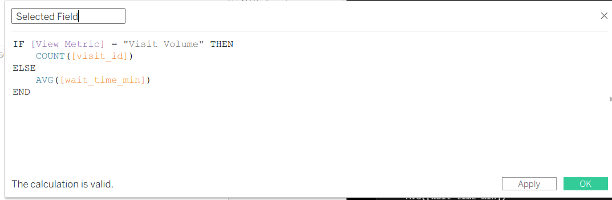

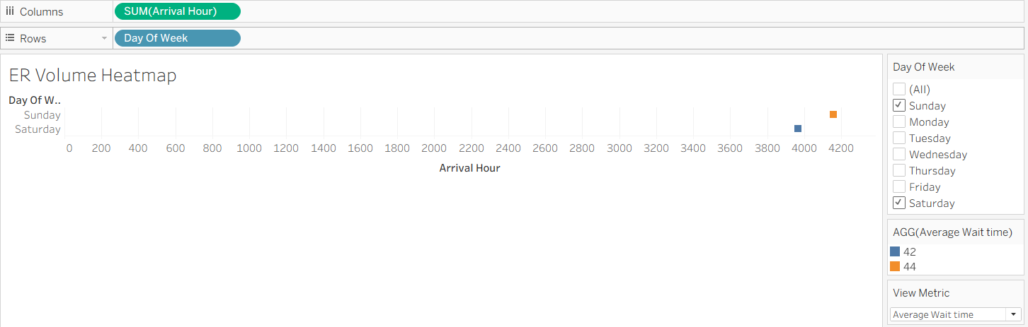

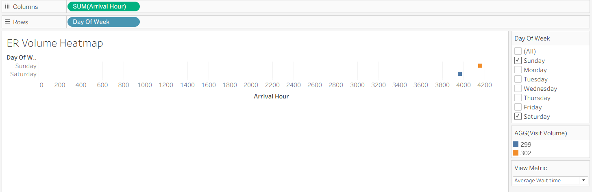

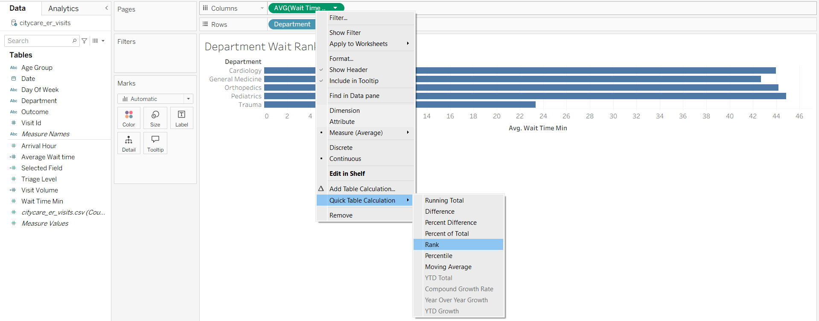

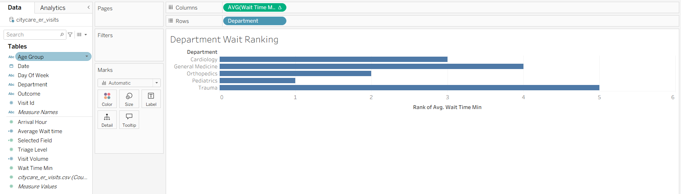
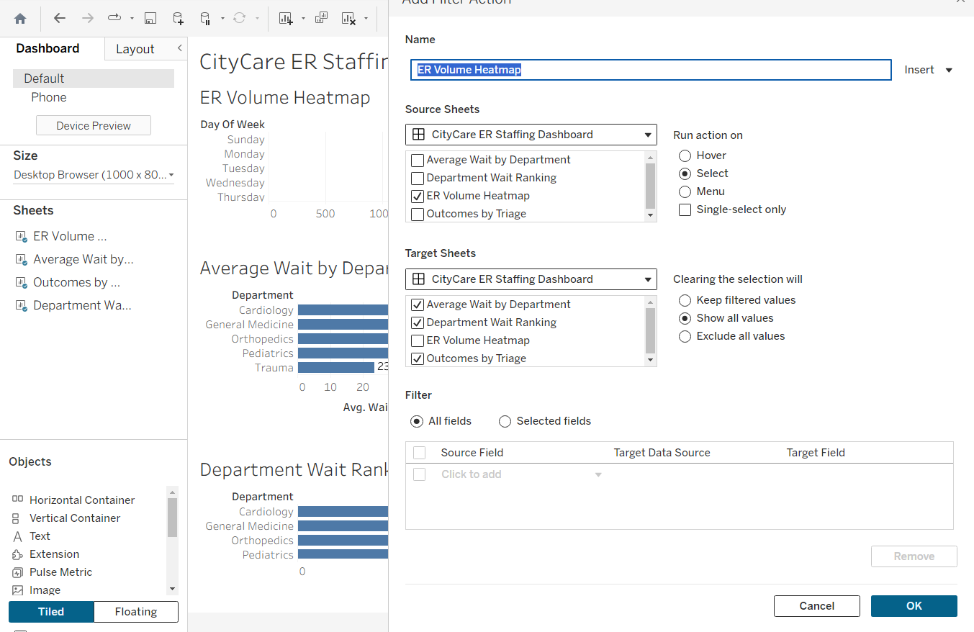

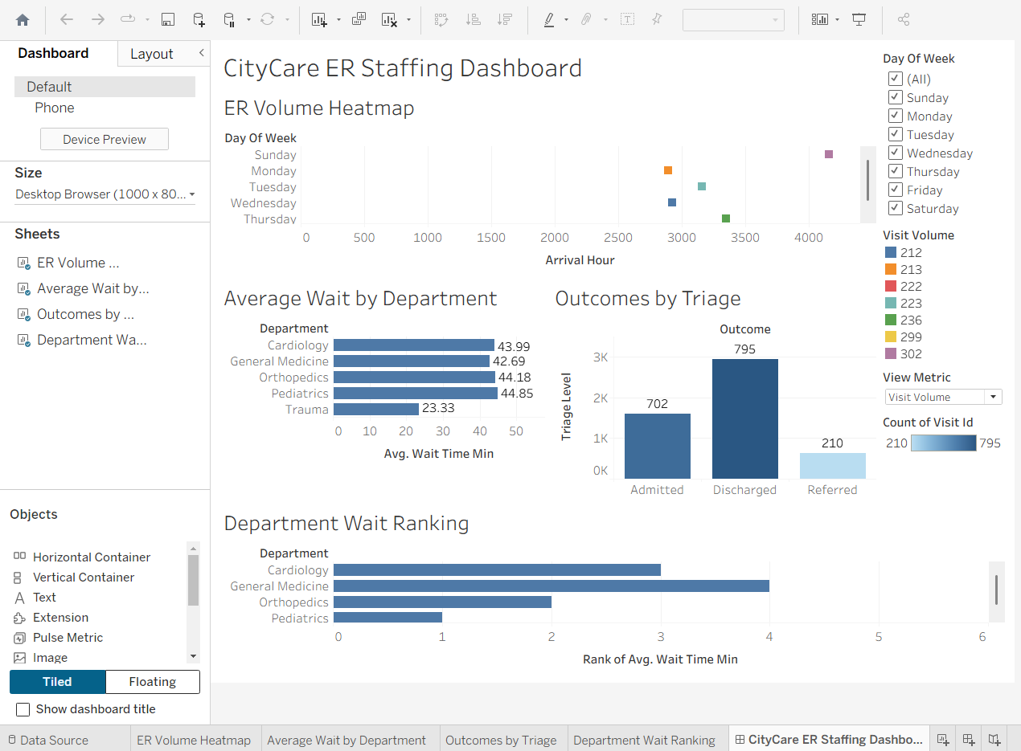

LAB 3 — OPENAI (CHATGPT)
SupportDesk: Turning Trapped Tacit Knowledge Into a Rule-Based Troubleshooting Guide Concepts covered: knowledge management (tacit vs. explicit, the SECI model), rule-based models.

Scenario
SupportDesk's customer support agents have quietly built up years of troubleshooting know-how, but almost none of it is written down anywhere official — it lives in scattered ticket notes and in each agent's head. New hires take months to become as fast as the veterans, simply because nobody has ever externalized what the veterans already know. You've been asked to use an AI tool to read a sample of resolved tickets and draft the beginnings of an official, rule-based troubleshooting guide — exactly the externalization step the SECI model describes.

Dataset: supportdesk_tickets.csv
- ticket_id, issue_category, agent_notes (free-text resolution notes), resolution_time_min, resolved_first_contact (Y/N), customer_satisfaction (1–5)
- 135 real-sounding resolved tickets across five categories: Login Issue, Billing, Bug Report, Feature Request, and Performance.

Tasks
- Upload or paste the agent_notes for the Login Issue and Billing tickets into ChatGPT. Ask it to identify the 3–5 most common root causes described across the notes.

The 3–5 most common root causes across the notes are:
- Application/product bugs and race conditions
  - Examples: duplicate rows from concurrent bulk edits, filters resetting after refresh, duplicate notification emails, broken Safari exports, and search indexes not rebuilding.
  - This is the broadest recurring theme.
- Performance and scalability limitations
  - Examples: report timeouts during peak hours, slow APIs caused by unindexed custom fields, large datasets causing slow dashboards, upload timeouts, and mobile memory issues.
  - Several issues appear tied to system capacity or scaling rather than individual customers.
- Authentication/login configuration and access issues
  - Examples: outdated bookmarked URLs, browser cache/cookie problems, extensions blocking auth cookies, delayed 2FA SMS, and false-positive account suspensions.
  - These repeatedly caused customers to be unable to log in despite their accounts being otherwise valid.
- Billing/checkout workflow and configuration problems
  - Examples: failed webhook retries causing duplicate charges, cancellation flow UX failures, incorrect currency localization, invoice-template bugs, and coupon expiry confusion.
  - A mix of genuine system defects and confusing billing workflows.
- Product UX limitations/confusing behavior
  - Examples: confusing-but-correct proration calculations, missing dark mode, lack of Excel import, and requests for audit logs or comparison features.
  - These aren't always technical failures, but they repeatedly generate support contacts because the product doesn't match user expectations or workflows.
Overall: The strongest recurring themes are product defects, performance/scalability, and login/access problems, with billing workflow issues and UX/product gaps forming the next tier.

- For each root cause identified, prompt ChatGPT to draft an IF-THEN rule in the style covered in class (e.g., “IF customer reports X AND Y THEN try Z first”) that a new agent could follow without needing the tacit experience the notes came from.

IF–THEN rules for new agents

- Product/UX workflow defects
IF a customer reports an unexpected result after completing a multi-step workflow (e.g., cancellation not recognized, filters resetting, confusing proration) AND their actions appear to have been completed correctly, THEN first verify the workflow status in the system logs and check whether the relevant state was successfully saved or persisted before assuming customer error.

- Infrastructure/system reliability issues
IF multiple customers report missing search results, duplicate charges/emails, or duplicate records AND the issue follows a migration, deployment, webhook retry, or concurrent action, THEN first check the relevant background process, index, job, or retry logs for failures or duplicate execution before applying a customer-specific workaround.

- Performance/scalability limitations
IF a customer reports slow reports, dashboards, charts, or API responses AND the problem occurs with large datasets, custom fields, or during predictable peak hours, THEN first identify the dataset size, timing, and indexing status; enable or recommend appropriate indexing or aggregation before treating it as an isolated application bug.

- Authentication/access configuration problems
IF a customer cannot log in, is unexpectedly suspended, has repeated session expirations, or cannot receive a 2FA code AND the problem is limited to a particular device, browser, account, or authentication method, THEN first check for known configuration or external-dependency causes (old URLs, blocked cookies/extensions, fraud-rule flags, or SMS delivery delays) before escalating as a general login defect.

- Billing/localization/configuration issues
IF a customer reports an incorrect charge, coupon, currency, or invoice problem AND the transaction appears inconsistent with their account configuration or billing history, THEN first verify the billing record, account settings, and applicable rules (such as coupon expiry, currency, invoice-template limits, or duplicate transaction attempts) before issuing a correction or refund.

- Cross-check: pick 5 tickets ChatGPT didn't explicitly reference, and test whether your drafted rules would have actually resolved them. Note any rule that fails and refine it.

I’ll use tickets #4, #11, #22, #28, and #38, which were not explicitly referenced in the drafted rules.
Ticket | Rule tested | Would the rule work? | Result/refinement
#4 | Authentication/access | Yes | The customer used an old bookmarked URL after a domain migration. The rule correctly directs the agent to check known URL/configuration causes before treating it as a general login defect.
#11 | Authentication/access | Yes | The account was incorrectly suspended by a false-positive fraud rule. Checking account-specific configuration/flags would lead the agent toward the correct escalation.
#22 | Authentication/access | Yes | The missing 2FA code was caused by an SMS carrier delay. The rule explicitly includes external authentication dependencies such as SMS delivery.
#28 | Billing/localization/configuration | Yes | The coupon had expired. Verifying billing rules before treating the issue as a system defect would reveal the expiration and allow the agent to explain it or issue goodwill credit.
#38 | Performance/scalability | Yes | The customer's 2M-row dataset lacked indexing. The rule directs the agent to check dataset size and indexing before treating the issue as an application-wide bug.
Rule refinement
The rules mostly held up, but the authentication rule could be made more actionable. A new agent should not merely "check for known configuration causes"; they need a sequence of checks.
Refined rule:
IF a customer cannot log in, is unexpectedly suspended, has repeated session expirations, or cannot receive a 2FA code THEN first determine whether the problem is specific to the URL, device/browser, account security status, authentication method, or external delivery service; THEN check the corresponding configuration/logs before escalating it as a platform-wide login bug.
The performance rule could similarly distinguish customer-specific scaling problems from systemic capacity problems:
IF performance is slow THEN first check whether the issue affects one customer or many, whether it occurs at a predictable peak time, and whether dataset size/indexing is involved; THEN use indexing/aggregation for customer-specific data problems and escalate capacity issues when multiple customers are affected at the same time.

- Ask ChatGPT to flag which tickets look like they reveal a product bug rather than a one-off user error — compare its picks against the Bug Report category and see how well they line up.

Product bug vs. one-off user error
Looking across the tickets, the ones that most clearly look like product/system bugs rather than one-off user errors are:
- #1, #26, #30 — Billing: cancellation flow failed to properly confirm the customer's cancellation.
- #2, #33 — Bug Report: search index failed to rebuild after migration.
- #3 — Billing: webhook retry created a duplicate charge.
- #10 — Bug Report: dashboard filters were not persisted across refreshes.
- #16 — Billing: invoice template failed for enterprise invoices with more than eight line items.
- #17, #19 — Bug Report: concurrent bulk edits caused a race condition and duplicate rows.
- #36 — Bug Report: duplicate cron job caused duplicate notification emails.
- #13, #18 — Bug Report: charting library had a >10,000-row rendering limitation.
- #8, #12 — Performance: peak-hour report timeouts suggest a capacity problem.

These picks line up quite strongly with the Bug Report category: most of the explicit Bug Report tickets describe reproducible system defects. However, the category understates the number of actual product problems because several tickets labeled Billing, Login Issue, or Performance also contain clear engineering defects. For example, #3 is categorized as Billing but is actually caused by webhook retry logic, while #16 is Billing but exposes an invoice-template bug.

By contrast, tickets such as #4 (old bookmark), #15/#29/#32 (browser extension blocking cookies), and #28 (expired coupon) look much more like user/environment-specific issues or expected behavior.

- Write a short reflection: which parts of the agents' knowledge were easy to turn into clean rules, and which parts resisted being reduced to a rule at all? Why might that be?

The easiest knowledge to turn into clean rules was technical troubleshooting knowledge with observable signals. For example, large datasets plus slow performance suggests checking indexing; duplicate charges suggest checking webhook retries; and login failures can be narrowed down by device, browser, URL, or authentication method. These situations have identifiable symptoms and relatively clear first diagnostic steps.
The harder knowledge to reduce to a rule was judgment about whether something is a customer problem, a product bug, or a broader infrastructure issue. Some tickets look similar on the surface but have very different causes. A slow report might be caused by a customer's 2M-row dataset or by peak-hour capacity. A login problem might be an outdated bookmark, a browser extension, an incorrect fraud flag, or an SMS carrier issue.
This suggests that experienced agents are not just following procedures; they are recognizing patterns and deciding which explanation is most plausible from incomplete evidence. That tacit judgment is difficult to capture in a single IF–THEN rule. The best rules therefore need both a clear first action and a small set of diagnostic questions that help the agent branch to the right cause.

Deliverables
- The drafted rule set (5–10 IF-THEN rules) with the ticket evidence behind each one.
- The cross-check results and the reflection summary (150–200 words).

LAB 4 — NOTEBOOKLM
Which Forecasting Method Actually Wins, Region by Region?
Concepts covered: business forecasting model comparison, logic-driven vs. data-driven reasoning, synthesis and interpretation.

Scenario
A national retailer tested six different forecasting methods against five years of regional sales data and logged the accuracy of each. Nobody has ever sat down and actually synthesized the results into a recommendation — the accuracy numbers just sit in a spreadsheet, and the regional analysts' notes about what makes each region's demand pattern unusual sit in a completely separate document. Your job is to bring an AI notebook tool to bear on both sources at once and produce the executive summary nobody's written yet.

Datasets: forecast_method_accuracy.csv and region_notes.csv
- forecast_method_accuracy.csv: region, method, mape_percent, rmse, method_description — all 5 regions tested against all 6 forecasting methods covered in Unit III (30 rows).
- region_notes.csv: a short analyst note per region describing its demand pattern in plain language (e.g., strong festive-season spikes, flat demand, monsoon-season surge).

Tasks
- Upload both CSVs to a new NotebookLM notebook as sources (you may also paste in the raw text if direct CSV upload isn't available in your version).
- Ask NotebookLM: “Which forecasting method performs best in each region, and does that match what the analyst notes say about each region's demand pattern?”
- For any region where the best-performing method surprises you, ask NotebookLM to explain, using only the provided sources, why that method might be winning there.
- Ask NotebookLM to identify the one region where the simplest methods (naive or simple exponential smoothing) actually perform competitively — and to explain, from the analyst note, why added complexity isn't paying off there.
- Generate an audio overview (or a written executive summary if audio isn't available) recommending one default forecasting method per region for the retailer to adopt.
- Write a 150-word critique: where did NotebookLM's synthesis genuinely add insight beyond just reading the spreadsheet yourself, and where did it just restate the numbers?

Deliverables
- The notebook's region-by-region method recommendations (exported or copied into a document).
- The audio overview link and written executive summary, plus the 150-word critique.

Notebook Chat Link:

https://notebook.google.com/notebook/d13845f5-a11a-4cad-aab9-21ec7a7cb2c9

Audio Link:

https://notebook.google.com/notebook/d13845f5-a11a-4cad-aab9-21ec7a7cb2c9/artifact/e557571b-3d13-4184-9dda-eaaf3b858a18?utm_source=nlm_web_share&utm_medium=google_oo&utm_campaign=art_share_1&utm_content=&utm_smc=nlm_web_share_google_oo_art_share_1_
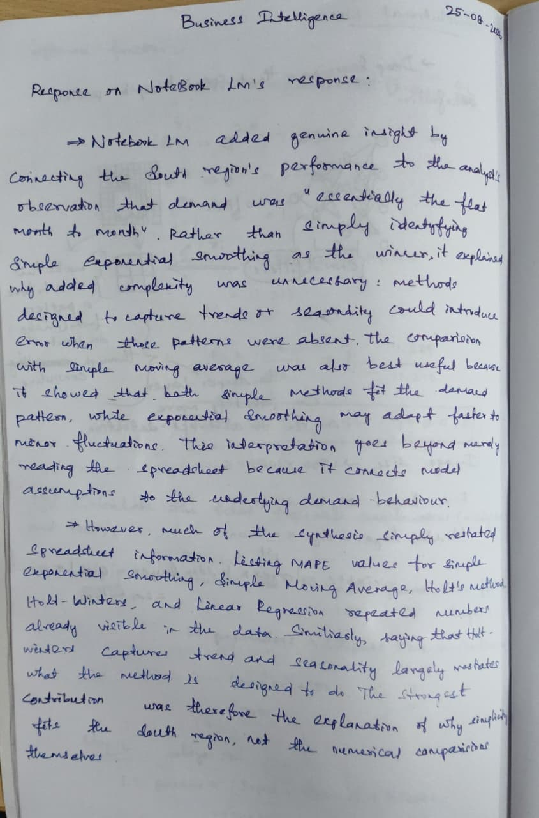

Dataset Files Provided
File | Contents
pedalshare_trips.csv | Bike-share trip log for Lab 1 (Power BI)
citycare_er_visits.csv | Hospital ER visit log for Lab 2 (Tableau)
supportdesk_tickets.csv | Customer support ticket log with agent notes for Lab 3 (OpenAI)
forecast_method_accuracy.csv | Forecast method accuracy by region for Lab 4 (NotebookLM)
region_notes.csv | Analyst commentary per region, paired with Lab 4

